Birth to Twenty: the assessment of physical development in adolescence
Year 14
ID:
Male
Section A

We would like to ask you a few questions about your physical development.

Question 1
Have you grown taller in the last 6 months?
(Please mark the appropriate block)

No Yes, a little Yes, some Yes, a lot Don’t know

Question 2
Do you have to shave your face because you have facial hair?
(Please mark the appropriate block)

No Yes, a little Yes, some Yes, everyday Don’t know

Question 3
Have you started puberty (i.e. do you have pubic hair or have your genitalia enlarged)?
(Please mark the appropriate block)

No Yes

Question 4
Has your skin started to change (pimples)?
(Please mark the appropriate block)

No Yes, a little Yes, some Yes, a lot Don’t know

Question 5
Has your voice started breaking (do you speak in a deeper voice)?
(Please mark the appropriate block)

No Yes

If YES, have you been speaking in a deeper voice for more than two years?

No Yes

If YES, how old were you when your voice broke?

Section B

The drawings below show different amounts of pubic hair. A teenager passes through each of the five stages shown by these drawings. Please look at each drawing and read the sentences under the drawings. Then choose the drawing closest to your stage of hair development and mark it.

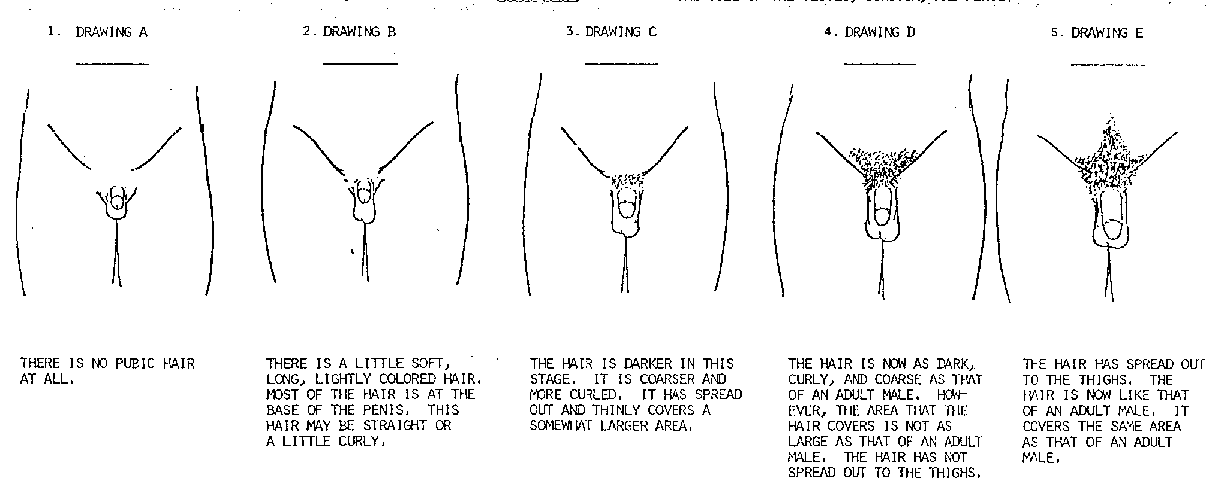

There is no pubic hair
Texture of the hair is soft.
Density of the hair is little.
Distribution of the hair is at the base of the penis, especially on the sides. Pubic hair may be straight or curly
Texture of the hair is coarse.
Density of the hair is that of an adult.
Distribution of the hair has spread to the thighs and moved up the mid-line.
Texture of the hair is coarser.
Density of the hair is a little more.
Distribution of the hair has spread out thinly and covers a somewhat larger area around the base of the penis.
Texture of the hair is coarse.
Density of the hair is much more.
Distribution of the hair covers a large area but has not spread to the thighs. The hair is a darker colour.

Section C

The drawings below show the different stages of development of genitals. A teenager passes through each of the five stages shown by these sets of drawings. Please look at each set of drawings and read the sentences under the drawing. Then choose the set of drawings closest to your stage of genital development and mark it.

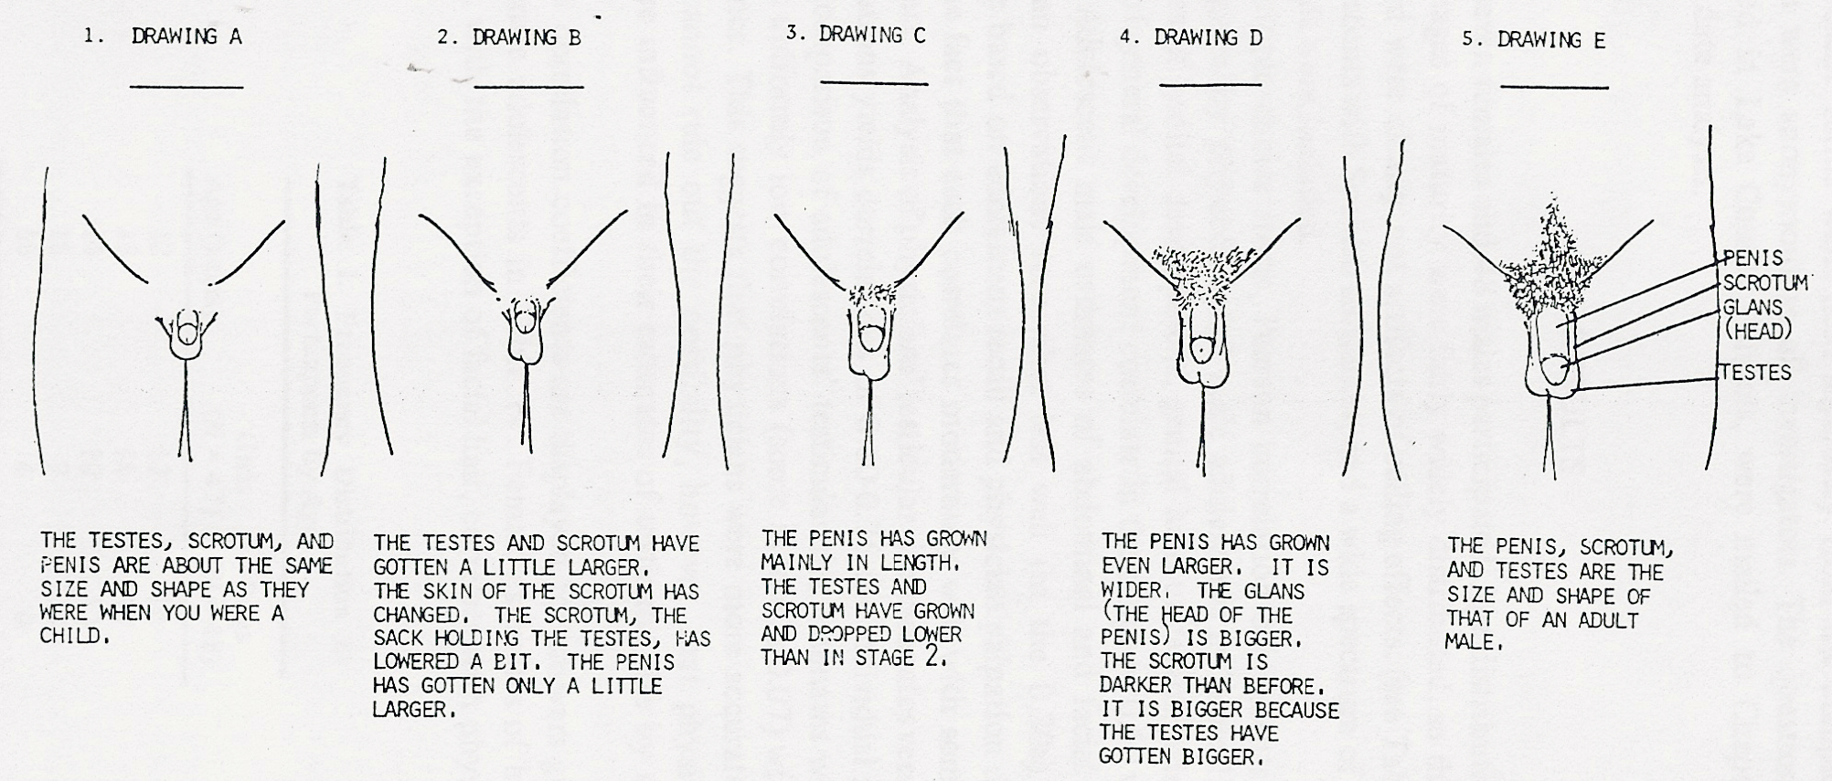

There has been no change in the testes (balls), scrotum (sack holding the balls), and penis.
The scrotum has lowered a bit, and the skin of the scrotum has changed (smoother). The testes, scrotum and penis have gotten a little larger.
There have been no further size changes in the penis, scrotum, and testes.
The scrotum has dropped lower than in stage 2. The testes, scrotum and penis have grown more.

The scrotum is bigger because the testes have gotten bigger. The penis has grown even larger and wider. The head of the penis is bigger

Section D

Testicular volume and size:

Interviewer
Year 14

